1.59: a) To three significant figures, the time for one cycle is

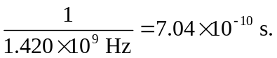

b) 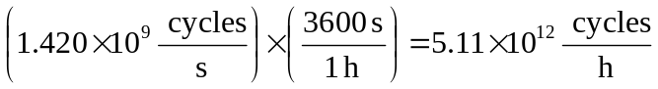

c) Using the conversion from years to seconds given in Appendix F,
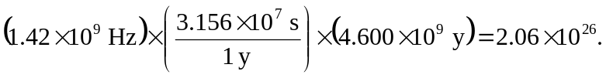
d)

